Name: Asiya Maryam A
SKILL VERSE – PROMPT ENGINEERING
Roll No.: E24AI004
Class/Section: Bsc – CS ( AI) 3rd year
Date: 19 August 2026

1.Prompt Card – Social Media Marketing Research Summary
AI USED : GEMINI NOTEBOOK
Level: Postgraduate
Purpose: Generate a concise academic summary of marketing research findings.
1. INPUT – Vague Prompt
“Write a summary about social media marketing research.”
OUTPUT – AI Generated Result:
Social media marketing research generally focuses on four key pillars:
- Audience Segmentation: Identifying demographics and psychographics to tailor content to specific user groups.
- Social Listening: Monitoring brand mentions and industry trends to understand public sentiment in real-time.
- Competitive Benchmarking: Analyzing competitors' engagement rates and content strategies to find growth opportunities.
- ROI Measurement: Correlating social metrics (like reach and clicks) with business goals like lead generation or sales.

2. INPUT – Structured Prompt
Key note : Gemini notebook also imported the most relevant papers.
Role: Marketing Research Analyst
Audience: Postgraduate students and academic researchers
Context: A research study examining the influence of social media marketing on consumer purchase intention among university students.
Task: Write a concise academic research summary explaining the study's purpose, methodology, key findings, and implications.
Format: 150-word summary followed by 4–5 keywords.
Constraints: Maintain an objective academic tone, use clear research terminology, avoid unnecessary background information, and do not invent statistics or findings.
Language: Formal Academic English.

3. OUTPUT – AI Generated Result

Research Summary:
This study investigates the impact of artificial intelligence (AI) integrated into social media marketing on the purchase intentions of Generation Z university students. Utilizing a quantitative research design, the study collected data from 487 respondents in Chennai through a structured questionnaire, subsequently analyzed via Partial Least Squares Structural Equation Modelling (PLS-SEM). The findings demonstrate that AI-driven marketing—characterised by personalization and automated responsiveness—significantly enhances brand trust, digital participation, and consumer citizenship behaviour. Notably, consumer citizenship behaviour emerged as the most potent determinant of purchase intention. Furthermore, Generation Z orientation was found to moderate and strengthen the relationship between AI-driven strategies and behavioural engagement. The research implies that marketers should leverage AI technologies to cultivate relational bonds and voluntary brand advocacy among digital natives. These insights provide an empirical framework for developing data-driven strategies within algorithm-centric digital ecosystems.
Keywords: AI-driven marketing, purchase intention, Generation Z, consumer citizenship behaviour, PLS-SEM.

2.Prompt Card #25 – Character Design

AI USED : CANVA IMAGE GENERATOR
Purpose: Generate a consistent fictional character.
1. INPUT – Vague Prompt:
“Create a warrior.”
OUTPUT – AI Generated Result:

2. INPUT – Structured Prompt
Role: Character Concept Artist
Subject: Female futuristic warrior
Context: Sci-fi video game
Appearance: Silver armor, short black hair, blue glowing eyes
Pose: Standing confidently
Environment: Futuristic city at night
Style: Cinematic concept art
Lighting: Blue neon rim lighting
Format: Full-body, 16:9
Constraints: Detailed armor, realistic anatomy.

3. OUTPUT – AI Generated Result


3.Prompt Card #27 – Code Generation

Purpose: Create background music for a video.
Vague: “Make some cinematic music.”

AI USED : CLAUDE
1. INPUT – Vague Prompt: “Create a website.”

Purpose: Generate a functional web application.

OUTPUT – AI Generated Result:

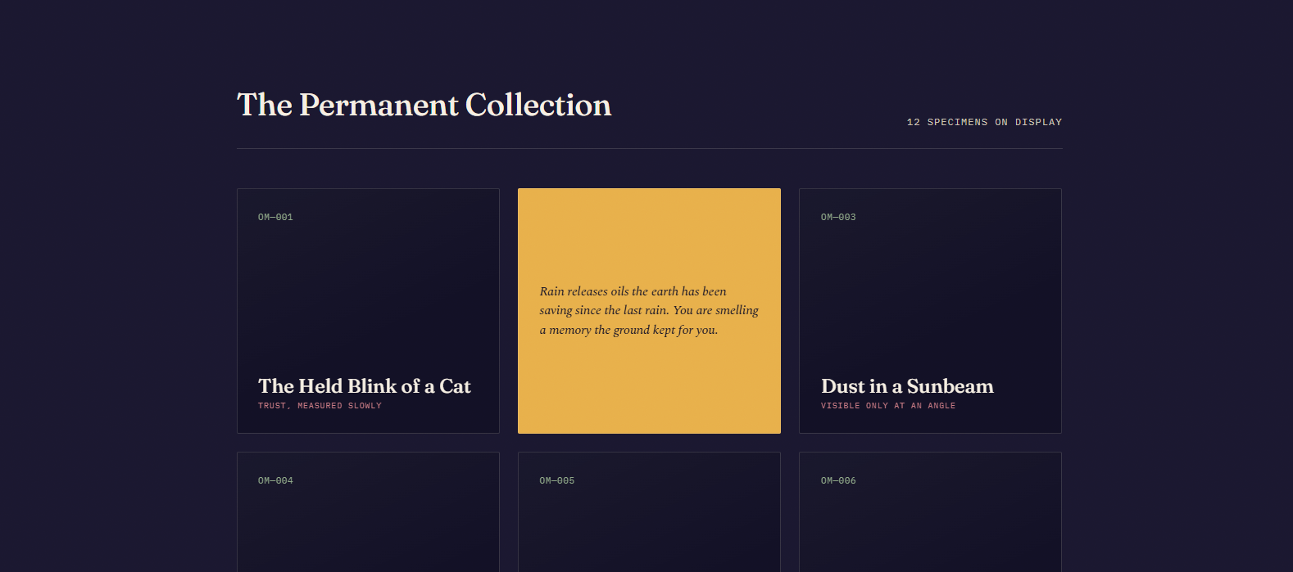
2. INPUT – Structured Prompt
Structured: Role: Full-Stack Developer | Audience: College Students | Context: Student task-management platform | Features: Login, task creation, deadlines, progress tracking | Technology: React, Node.js, PostgreSQL | Design: Clean and responsive | Format: Complete source code | Constraints: Mobile-friendly, accessible, secure authentication.

OUTPUT – AI Generated Result:

Why: Specifies the users, functionality, technology stack, design, and technical constraints.

4.Prompt Card #31 – Game Generation

AI USED : ROSEBUD AI
Purpose: Create a simple playable game.

1. INPUT – Vague Prompt: “Make a racing game.”

OUTPUT – AI Generated Result:

2. INPUT – Structured Prompt
Structured: Role: Game Designer | Audience: Casual Players | Context: Mobile arcade racing game | Genre: Racing | Gameplay: Players avoid obstacles and collect coins | Environment: Futuristic highway | Controls: Swipe left/right | Difficulty: Progressive | Format: Mobile game concept | Constraints: Simple controls, short gameplay sessions.
OUTPUT – AI Generated Result:
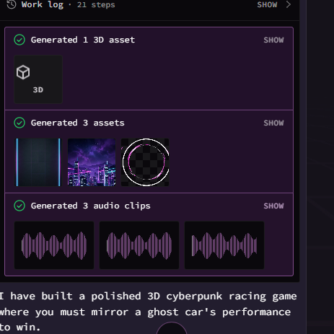



5.Prompt Card #33 – Data Visualization

Purpose: Turn complex data into an understandable visualization.
Vague: “Make a graph from this data.”

- INPUT – Vague Prompt: “Make a graph from this data.”

OUTPUT – AI Generated Result:
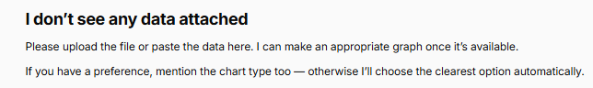

- INPUT – Structured Prompt

Structured: Role: Data Visualization Designer | Audience: Business Executives | Context: Five-year company revenue data | Goal: Show revenue growth and seasonal trends | Chart: Line chart | Colors: Company brand colors | Labels: Years and revenue values | Format: Presentation-ready graphic | Constraints: Minimal clutter, readable labels, highlight major changes.

OUTPUT – AI Generated Result:


